**Part 1: Sales**

**Question 1** (worth 5 marks)

Create a class diagram that supports the scenario.

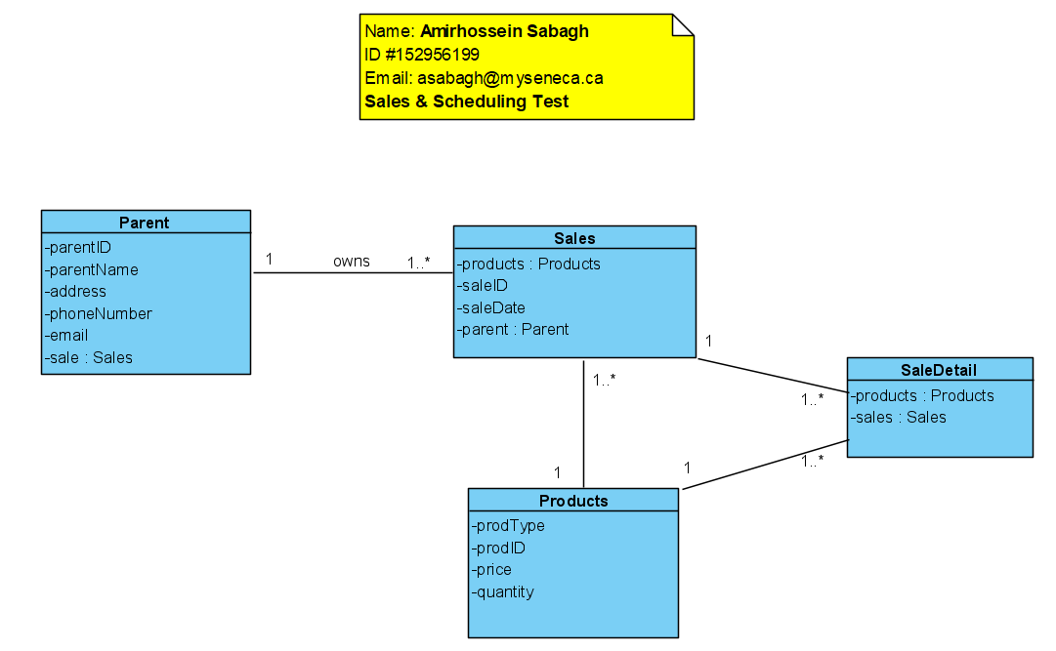

**Question 2** (worth 10 marks)

Complete Object Level Sequence diagrams to support the above scenario.

|  |  |  |  |
| --- | --- | --- | --- |
| Use Case Name | Record store sale of t-shirts | | |
| Triggering Event | Parent would like to purchase ProTKD branded t-shirts | | |
| Brief Description | Allows the Store Manager to record a new sale of t-shirts. | | |
| Actors | Store Manager | | |
| Related Use Cases |  | | |
| Preconditions | Store Manager has opened the Main Menu. | | |
| Post Conditions | Sale is saved to the database and now can be added to the parent’s end of the month bill | | |
| Flow of activities | Actor | | System |
|  |  | Requests to record a sale | Retrieves list of parents and prompts for selection. |
|  |  | Selects a parent | Display of item types. Prompts for selection. Creates Sale assigning a unique identifier and sale date. Assigns current semester the sale |
|  |  | Selects T-Shirts | Displays a list of t-shirts including price. Prompts for selection |
|  |  | Selects required t-shirt | Displays T-Shirt. Prompts for quantity sold |
|  |  | Enters quantity sold | Creates sale detail. Calculates taxes and total amount of the sale. Displays the t-shirts sold. |
|  |  | Repeats the above 2 steps until all t-shirts selected | Calculates taxes and total amount of the sale. Displays the t-shirts sold. Displays the sale. Prompts for confirmation |
|  |  | Confirms sale | Adds the sale transaction. |
| Exception Conditions | * Store Manager chooses to cancel adding the sale | | |

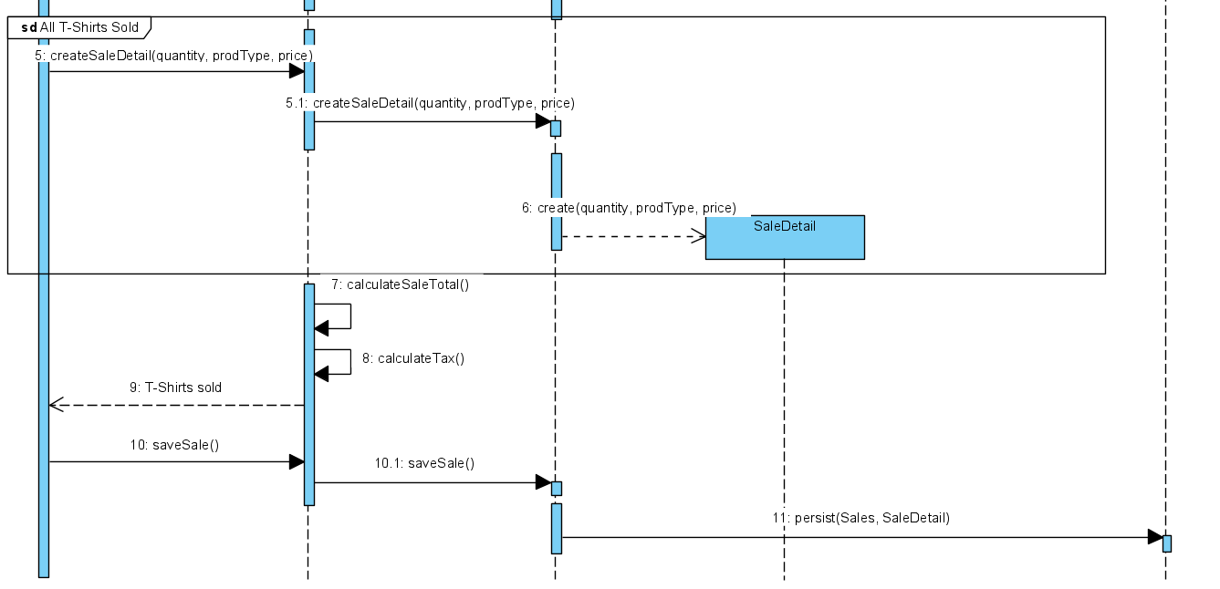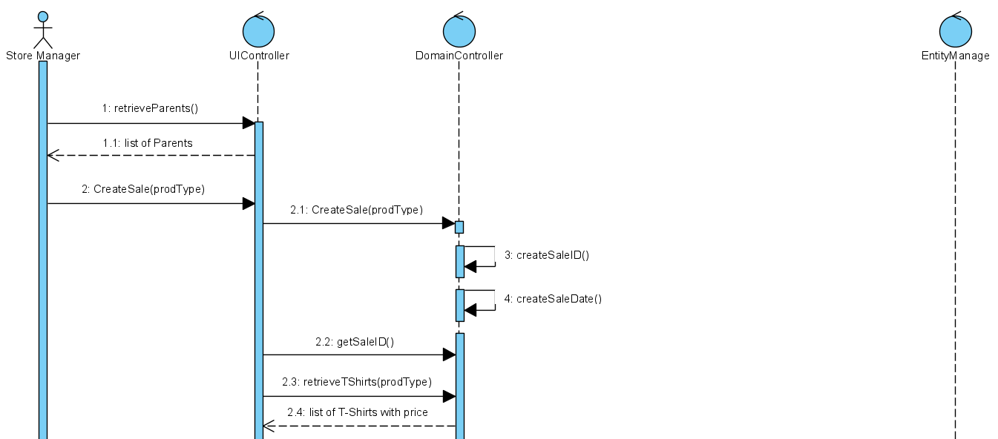

Retrieve Parents:

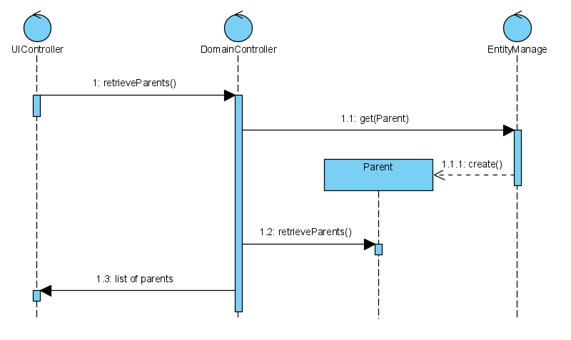

Retrieve T-Shirts:

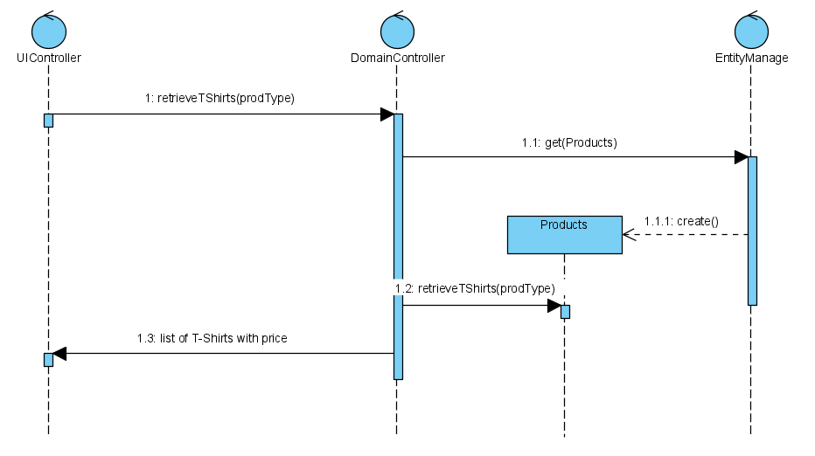

**Question 3** (worth 5 marks)

The above scenario assumes that t-shirts are one size fits all. What would happen if ProTKD decided to stock t-shirts in different sizes? Please describe in English how you change the current model to support the new requirements.

**I would add an attribute called 'size' to the Products class diagram and also modify the messages in the sequence diagram so the next time, as well as quantity, the store manager should enter the size of the products, in this case the size of the T-Shirt, in order to retrieve the correct sold T-Shirts.**

**Question 4** (worth 5 marks)

As well as licensed merchandising, the ProTKD store sells snacks including granola bars and water. One of their suppliers has a recall on their granola bars because of bacterial contamination. ProTKD must contact parents who may have purchased the affected product. How ProTKD use your model to support this request? Please describe, in English, any changes to your model that should be made to support this request.

**I already designed a sequence diagram to help the store manager retrieve the list of Parents. We could modify the diagram so we would get the phone number of parents that purchased granola. The store manager could pass the product type as a parameter and our modified sequence diagram would check and retrieve the phone number of all the parents that bought that product type.**

**Part 2: Scheduling**

**Question 5** – Class Diagram (worth 10 marks)

Your task is to create a class diagram to support the activity and the scenario described below.

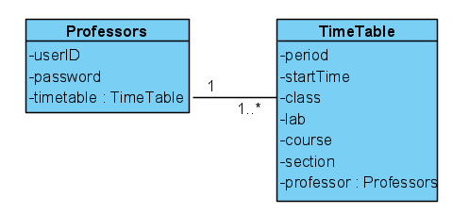

**Question 6** – Sequence diagram (worth 5 marks)

Please complete an object level sequence diagram to support the above scenario.

